Contributor: Gustavo Larach

**Zelaya Sierra, Pablo**

Born: 1896 – Ojojona, Honduras; Died: 1933 – Tegucigalpa, Honduras

Pablo Zelaya Sierra was one the earliest Honduran artists to engage in modernist pictorial practices. He was still a teenager when he travelled on foot from his native rural hometown to Tegucigalpa, Managua, and San José, sojourning in each of these Central American capitals in search of exchanges with other artists. In 1920, funding from the Honduran government allowed him to start studies at the Academia de San Fernando in Madrid, where he studied under Manuel Benedito (1875–1963), a student of Joaquín Sorolla y Bastida (1863–1923), and also under Daniel Vásquez Díaz (1882–1969). During his years in Europe (1920–1932), Zelaya became conversant with modernist pictorial languages, particularly Post-Impressionism, while also becoming an adept draughtsman and painter of academic pictures. Most of his works are undated, yet his known oeuvre belongs largely to this sojourn in Europe. Zelaya used repetition, rhythm and harmony of organic as well as geometric form to construct a world that appears preindustrial, sometimes marked by rural labour, sometimes engaging with the tropes of ‘primitivism’, and sometimes completely idealising rural life.

In the painting *Los Arqueros,* the unifying motif is the man with an arched bow, who echoes the famous statue in Paris by Antoine Bourdelle. The composition of *Los Arqueros* is pulled together by the repetition of the arc; yet the overlapping of arched forms also flattens the picture. Forms are thus compressed on the picture plane, and the tensions and ambiguities created by placement and proportion of forms is reminiscent of Paul Cézanne’s work. Cézanne’s palette and way of approaching volume by modulating colour can also be perceived in this work.

The work *Paisaje [con] hombre segando*, a good example of Zelaya´s post-impressionistic idiom, conveys a more realist representation of people’s relationship to the land. In it, Zelaya broadened the scope of his palette and through a more analytical modulation of colour created a more compelling evocation of light. In the far distance, the tall pipes of industrial chimneys can be seen. Still in the background of the image, the great buildings of an urban centre rise against the sky. In the middle ground, long, thick walls run enclosing a large expanse of land. Outside that domain, with his back turned to the urban setting, a man inclines himself over the soil. The title suggests he is reaping or clearing; his work seems menial, and his existence, a few small marks of blue over a minimal portion of the canvas, of almost no consequence.

Before returning to Honduras in 1932, Zelaya had his last exhibition in Europe, at the Ateneo de Madrid. In this show, the most acclaimed works were those that, like *La mujer y el niño*, show native women in a rural setting. A prominent Spanish critic of the time, Gil Fillol, commended the *indigenista* turn these works entailed within Zelaya’s production: “El carácter americano—precolombino, mejor dicho—tan patente en *Dos muchachas*, *Muchacha del guacal*, *La aldea*, *Mujer y niño*, etc., es matiz de sensibilidad del que, a mi juicio, [el artista] no debe desprenderse, cualquiera que sea su orientación definitiva” (López and Becerra 1991: 25). *La mujer y el niño* presents a configuration radically different from that of *Paisaje [con] hombre segando*; the pictorial idiom has changed yet again into a composition of subdued colours and highly simplified forms. A seemingly monumental female figure stands in the foreground and a dirt road slopes up behind her into a small house. Her left foot sits on a stone, a light-skinned child rests on her raised thigh. The forms of the female figure are bulky and heavy, as if made from coarsely carved, thick blocks of wood. They depict a strong, colossal woman of dark skin. If the relationships between the elements in this work might raise questions about identity and social roles in a presumably rural, Central American context, other works in the 1932 exhibition, like *Muchacha del huacal*, present an idyllic world of rural utopian bliss. One would have expected Zelaya to mature this germinating *indigenismo,* yet the social panorama awaiting him in Honduras stored unforeseen developments.

The first decades of the 20th century had been a time of political unrest and civil war in Honduras, with liberals and conservatives fighting each other, creating militias out of citizens from both urban and rural spheres. Zelaya returned to Honduras in October of 1932. In November of that year conflict broke out again. A painting he made at his return suggests Zelaya had come into contact with the brutal reality of his country. *Hermanos contra hermanos*, an image of horrible carnage, is extremely divergent to the peaceful paintings shown in Madrid only months earlier. Zelaya had brought with him many of his paintings to Honduras, and had outlined in writing an artistic agenda for his country. He wanted Hondurans to reveal their own personal worlds through art (Zelaya Sierra 1990). His vision would have to wait several decades.

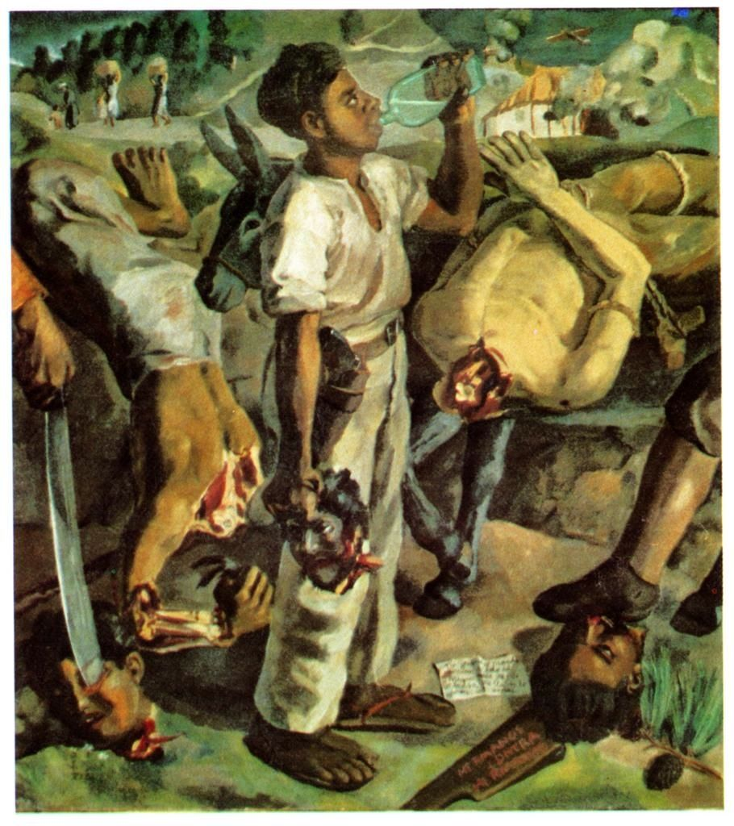

[Pablo Zelaya Sierra, *Hermano contra hermano (Brother against Brother),* 1933, oil on canvas, Collection: Banco Atlántida](http://library.artstor.org/library/%22%20%5Cl%20%223%7Csearch%7C1%7Czelaya20sierra%7CMultiple20Collection20Search%7C%7C%7Ctype3D3126kw3Dzelaya20sierra26id3Dall26name3DAll20Collections)

**Further Reading:**

Argueta, Mario (1996), *Diccionario de artistas plásticos hondureños* (Choluteca: Subirana).

Fiallos, Rául (1989), *Datos históricos sobre la plástica hondureña* (Tegucigalpa: Litografía López).

Kupfer, Monica E. (1996), 'Central America', in Edward J. Sullivan (ed.), *Latin American Art in the Twentieth Century* (London: Phaidon Press).

López, Evaristo and Becerra, Longino (1991), *Pablo Zelaya Sierra: vida y trayectoria artística* (Tegucigalpa: Baktún Editorial).

Suárez, Clementina (1984), 'Ausencia y presencia de Pablo Zelaya Sierra', *Revista de Arte*, 6-8.

Zelaya Sierra, Pablo (1990), 'Apuntes a lápiz', (Tegucigalpa: Secretaría General de Cultura).

**List of Works:**

Pablo Zelaya Sierra, *Los arqueros (Archers)*, undated, tempera on canvas, 178.5 x 207 cm. Banco Central de Honduras

Pablo Zelaya Sierra. *Paisaje [con] hombre segando (Landscape with Man Reaping),* undated, oil on canvas, 73 x 63.5 cm. Instituto Hondureño de Antropología e Historia

Pablo Zelaya Sierra, *La mujer y el niño (Woman and boy),* c. 1932, oil on canvas, 96 x 70 cm.

Pablo Zelaya Sierra, *Muchacha del guacal (Girl of the Gourd)*, c. 1932, oil on canvas, 94.6 x 80.3 cm. Banco Central de Honduras

Pablo Zelaya Sierra, *Hermano contra hermano (Brother against Brother),* 1933, oil on canvas, Collection: Banco Atlántida